Vocational school for computer programming and innovation



School project

Theme:

Struct project

|  |  |
| --- | --- |
| Prepared by:  Aleksander Dinev  Dimitar Kalchev  Kaloyan Andrikov  Aleksander Patrashkov | Consultant:  Petar Georgiev |
| Burgas 2020 | |

**Contents**

1. Theme 3

2. Authors 3

3. Consultant 3

4. Summary 4

4.1. Goals 4

5. Project complexity level 4

5.1. Logical and functional description of the solution 4

5.2. Functions 4

5.2.1. Class Data 4

5.2.2. Class Presentation 5

Table 1 3

Table 2 3

Table 3 5

Table 4 6

Figure 1 4

# Theme

The main idea of ​​the project is to help tournament organizers create tournaments.

# Authors

Our team consist of four members. The contact information and respective roles are descripted in Table 1:

|  |  |
| --- | --- |
| Members | Role |
| Aleksander Galinov Dinev - IX V | Manager, Developer |
| Dimitar Milenov Kalchev - IX A | Designer, Developer |
| Kaloyan Nikolaev Andrikov - IX G | Designer, Developer |
| Aleksander Kostadinov Patrashkov - IX B | Designer, Developer |

Table

# Consultant

|  |  |
| --- | --- |
| Name: | E-mail: |
| Petar Georgiev |  |

Table

# Summary

## Goals

Our goal is to help event creators to deal easier with the tournament management. ​

# Project complexity level

Making our project we encountered many problems. For example, we had a problem with calculating the duration of the tournament. Another problem was checking for correct inputs in create a tournament option.

## Logical and functional description of the solution

Here is a block scheme of our project:

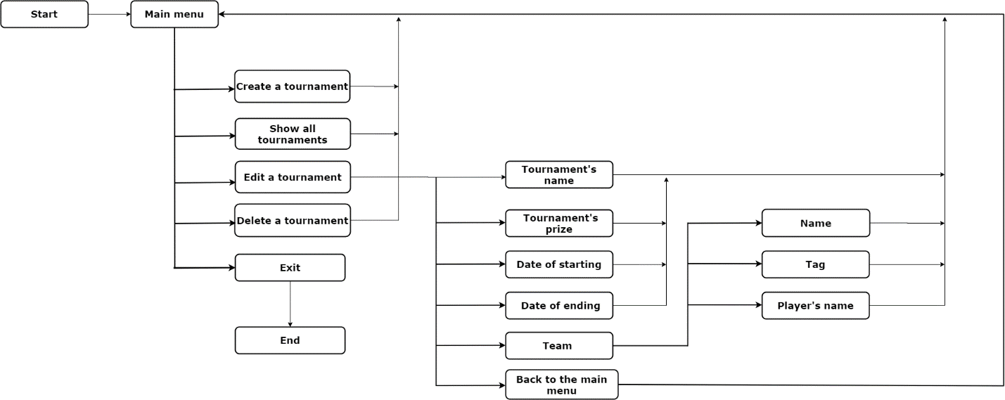

Figure

## Functions

### Class Data

|  |  |  |
| --- | --- | --- |
| Name | Parameters | Description |
| createTournament | Tournament: a pointer to an array of TOURNAMENT_INFO elements. This array stores all records related to tournaments | A function that stores the given data and creates a tournament from it. |
| deleteTournament | Index: an integer that specifies the position of the element to be deleted | A function that deletes a tournament by given index |
| getTournamentIndexById | Id: an integer that uniquely identifies a record in the array | A function that returns the index of the tournament with the given id. If there is not any tournament with that id the function returns -1 |
| checkIncorrectDate | start, end, duration: arguments that specify start, end and duration for a particular tournament | A function that checks if the given time of starting is after the given time of ending. If it is, the function returns true, if not it returns false |
| checkTeamNumber | number: an integer that is to be checked that is valid team number  id: an integer that uniquely identifies a record in the array | A function that returns true if a team with the given number exists. If the team does not exist, it returns false |
| checkPlayerByNumber | number: an integer that is to be checked that is valid player count  id: an integer that uniquely identifies a record in the array | A function that returns true if a player with the given number exists. If the player does not exist, it returns false |

Table

### Class Presentation

|  |  |  |
| --- | --- | --- |
| Name: | Parameters: | Description: |
| displayMenu | isEntered: an integer that stands to check if we already have created tournament | A function that display the menu options |
| displayTournament |  | A function that returns nothing and display the entered tournaments to the user |
| printDuration | Id: an integer that uniquely identifies a record in the array | A function that returns nothing and display the tournament’s duration by the given id |
| editTournament | editChoice: an integer that is used it the switch options  id: an integer that uniquely identifies a record in the array | A function that returns nothing and is used to edit something in a tournament by the editChoice |
| editTeam | Choice: an integer is used in the switch options  Id: an integer that uniquely identifies a record in the array  teamIndex: an integer that identifies the index in teams array | Aa function that returns nothing and is used to edit something in a team |
| editTournamentMenu |  | A function that returns nothing and show the edit options to the user |
| deleteTournamentMenu |  | A function that returns nothing and is used to ask the user which tournament he want to delete |
| createTournamentMenu |  | A function that returns nothing and is used to add the information for the new tournament |
| menuChoice | isEntered: an integer that stands to check if we already have created tournament | A function that manages the main menu |

Table